e-Parliament Programme – Amendments Workflow
“AM Batch” Interim Solution
PURE-XML Storage Guidelines

Changes Follow-Up
Version | Date | Author(s) | Description
1.0 Draft | 28/01/2013 | PROMS | Creation
1.1 | 30/01/2013 | PROMS | Internal revision
1.2 | 31/01/2013 | PROMS | Revision after internal discussion on 30-Jan

References
ID | Title | Version | Status | Description
[1] | “AM Batch” Interim Solution  Policy Side Process | 1.1 | Draft | TO-BE process for the part of the AM Batch interim solution that specifically refers to the creation and verification within DLA (using the new e-Parliament component DST) of AM documents.
[2] | “AM Batch” Interim Solution  Translation Process | 1.2 | Draft | TO-BE process for the part of the AM Batch interim solution that specifically refers to the translation of AM documents
[3] | “AM Batch” Interim Solution  IT System View | 1.1 | Draft | Technical aspects of the “AM Batch” interim solution, IT workflow and interdependencies of the applications involved.
[4] | PURE-XML Functional Specifications | 1.8 | Validated | Functional specifications of the Parliament Unique Repository for XML text production (PURE-XML).
[5] | Final Consolidation Ultimate IRO model.doc | 1.8 | Validated | Technical analysis made by the working groups of the IROs in order to prepare decisions, positions or recommendations for document management in the European Parliament
[6] | PURE-XML UDI Rules | 2.0 | Draft | Usage of the Unique Document Identifier (UDI) in the scope of e-Parliament, the versioning management rules and constraints, as well as the necessary provisions to implement the above document management pattern

Table of Contents
1 Introduction 7
1.1 Document Objectives 7
1.2 Definitions 7
2 PURE-XML Storage Guidelines 8
2.1 PURE-XML Folders and Object Names 8
2.1.1 Procedure Reference 8
2.1.2 XML4EP Doc Category 9
2.1.3 UDI of Logical Units 10
2.1.4 Two-Letter Language Code 10
2.1.5 Renditions MIME Type 11
2.1.6 PURE-XML Folder/Name Structure 11
2.1.6.1 Amendments and Compilations of Amendments 12
2.1.6.2 Media Files 13
2.2 Storage of Amended Document 15
2.3 PURE-XML System and Content Types Properties 15
2.3.1 Content-Types 15
2.3.2 Content-Type Properties 16
2.3.3 Content-Type Rendition-Level XML Metadata 16
2.3.4 PURE-XML System Properties 16
2.4 EPS PURE-XML Service Layer 17
2.5 Stages at which Content Must Be Saved in PURE-XML 20

List of Tables
Table 1 – XML4EP Doc Categories 9
Table 2 – Content-Type rendition-level XML metadata examples 16
Table 3 – Guidelines for setting PURE-XML system properties. 17
Table 4 – Steps in the amendments workflow when content is stored in PURE-XML 21

List of Figures
Figure 1 – PURE-XML folder structure 12
Figure 2 – PURE-XML folder structure for amendment logical units 13
Figure 3 – PURE-XML folder structure for global media files 14
Figure 4 – PURE-XML folder structure for specific media files 14

Introduction

Document Objectives
The objectives of this document are:
- Propose a structure for organising content in PURE-XML;
- Propose a scheme for naming objects in PURE-XML (folders, logical units, physical units, XML renditions and media);
- Provide an high-level description of the main methods provided by the EPS PURE-XML Service Layer that can be used by client applications (AT4AM, DST and CAT4TRAD) for storing content in PURE-XML;
- Identify the steps in the workflow when content is stored in PURE-XML.

Definitions
- EPS PURE-XML Service Layer:
An e-Parliament component providing high-level services for storing content in PURE-XML and encapsulating the setting of many PURE-XML properties, following the guidelines presented in this document.
- EPS-TPL:
An e-Parliament component interfacing with EPADES-II, PURE-XML, DM-XML and FILEBEANS that – at pre-defined EPADES-II steps – extracts content from PURE-XML, requests the generation of DocEP documents and DocEP notices, injects the DocEP files and/or the zip file of the Akoma Ntoso XML content in the circuit and saves document files in the EPADES file system.
- UDI and UBI
See the PURE-XML UDI Rules document drafted by PROMS team [6]

PURE-XML Storage Guidelines

PURE-XML Folders and Object Names
Because any PURE-XML object is uniquely identified by a Unique Business Identifier (UBI), which is independent of the object’s hierarchical position, the PURE-XML folder structure primarily serves the purpose of organising objects for facilitating access through the PURE-XML console, for example in maintenance operations.
The folder structure should be simple and based on immutable business-related properties of the objects.
The proposed folder/name structure will be based on the following information elements:
- Procedure reference folder names;
- XML4EP doc category folder names (under a “procedure” folder);
- UDI of logical units name of logical units;
- Two-letter language code name of physical units;
- MIME type name of Renditions.
The following paragraphs provide more detail on each of the above information items, while paragraph 2.1.6 – PURE-XML Folder/Name Structure describes how they are used together to build the complete folder/name path of objects in PURE-XML.
The concatenation of names: procedure_reference/doc_category/UDI/LL/mime_type leads to the last version of a given content (e.g. an amendment) in PURE-XML.
Note that in PURE-XML the name must be unique for the object’s versions series under a same folder; different versions of the same objects can have the same name. When PURE-XML is asked to provide an object by name, the last version is returned.

Procedure Reference
The majority of documents and content related to parliamentary activities refer to a given procedure, although in some cases – oral questions for example – a document is not referred to a procedure.
For documents such as reports, opinion, amendments, etc., the procedure reference is written within the document itself.
For those documents, the procedure reference can be effectively used to hierarchically structure content in PURE-XML.
Content stored in PURE-XML in the framework of the AM Batch interim is always related to a procedure.
Depending on the kind of object being stored, the procedure reference might or not be available within the XML4EP metadata (for example, the procedure reference is not present in the metadata of individual amendments). On the other hand a PURE-XML client application (AT4AM, DST or CAT4TRAD) always “knows” the procedure reference associated to an amendment or to an amendments batch, when needing to store content in PURE-XML.
The procedure reference format is yyyy/nnnn(XXX), where yyyy is the year in four digits, nnnn is a unique four-digit sequential number within a given year and XXX is the procedure type acronym.
Because the current format contains the forward slash and the parenthesis characters – which are not allowed for a folder name in PURE-XML – the forward slash and the first parenthesis shall be replaced by the underscore character; the last parenthesis is omitted.
The procedure reference used for the PURE-XML folder names must match the following regular expression:
[0-9]{4}_[0-9]{4}_[A-Z]{3}
For example: 2012_2056_INI

XML4EP Doc Category
The possible values of the mandatory XML4EP Doc category are defined within the e-Parliament program in a way to ensure consistency with the IROs document type classes and the RdM models.
Table 1 lists the categories currently defined in XML4EP. Please note the XML4EP doc categories are still being defined, but the values are “stable” as far as the categories referred to amendments are concerned (highlighted in bold in Table 1).

HREF | Description
xml4ep:/act/category/decision | Decision
xml4ep:/act/category/directive | Directive
xml4ep:/act/category/regulation | Regulation
xml4ep:/act/category/recommendation | Recommendation
xml4ep:/act/category/legislativeResolution | Legislative resolution
xml4ep:/act/category/jointText | Joint Text of Parliament and Council
xml4ep:/act/category/position | Official position of an institution
xml4ep:/act/category/resolution | Non legislative resolution
xml4ep:/doc/category/amendment | Generic amendment.
xml4ep:/doc/category/amendment/modification | Amendment of type "modification".
xml4ep:/doc/category/amendmentList | Generic amendments batch
xml4ep:/doc/category/report | Generic report.
xml4ep:/doc/category/report/recommendation | Report of type "recommendation".
xml4ep:/doc/category/opinion | Generic opinion
to be completed ...
Table 1 – XML4EP Doc Categories
A XML4EP category can have a hierarchical structure, as is for example the case of the “amendment” category, for which the “amendment/modification” sub-category is also defined.
This sub-categorisation is not needed for the PURE-XML folder structure, which can then be based on the top-level XML4EP category.
The XML4EP category is defined in the ep:category attribute of the element identified by the following XPath expression:
/akomaNtoso/*[1]/meta[1]/analysis[1]/otherAnalysis[1]/ep:instanceInfo[1]/ep:docClass[1]
Only the top-level category (the string after “/category/” and before the successive forward slash “/”) is taken.
In the framework of the AM Batch interim, the following XML4EP category values will be used for naming folders:
- amendment name of folder containing individual amendment objects
- amendmentList name of folder containing the “container” of amendments objects

UDI of Logical Units
The root object of a given individual amendment, amendments list or of an XMLised document to be amended is a logical unit.
The name of a logical unit can be univocally set – for the version series – to the UDI (see [6] for further details).
Characters (or sequence of characters) that are not allowed for folder names in PURE-XML are replaced by the underscore character.
UDI = authority:scheme:(year)ID
Logical Unit Name = authority_scheme_year_ID
Where ID is a unique ten-digit sequence reinitialised each year.
For example:
eu.europa.europarl_DIN1_2013_0123456789

Two-Letter Language Code
Physical Units represent the collection of files related to one specific language. Based on this definition, the two-letter language code can be used to name a physical unit (see [6] for further details).
This approach must be stretched to accommodate for mixed (panaché) language and for content that might not have a proper language, such as images without any linguistic content. In both cases the “XM” language code will be used.
Physical Unit Name = LL
Where LL is the two-letter language code as defined in ISO 639-1 standard, including the EP specific XM and XL codes.
For example:
EN
FR
XM

Renditions MIME Type
A rendition is characterised by its MIME type extension.
The MIME type can be used for naming a rendition, provided that the forward slash, typically used to separate category and sub-category (e.g. “image/jpeg”), is replaced by the underscore character: “_”.
Rendition Name = MIME Type
For example:
text_xml
image_jpeg
application_msword
Note that this approach has the consequence that only one type of rendition can be stored for a given physical unit (i.e. both a text/xml and an application/msword rendition could co-exist for the same physical unit, but not two text/xml renditions).
See [6] for further details.

PURE-XML Folder/Name Structure
Having defined the elements composing the path of objects in PURE-XML in the previous paragraphs, it is now possible to draw the PURE-XML folder/name structure.
Under the root PURE-XML folder, two top folders will be required: “Procedures” and “Media”.
The “Procedure” folder is the root folder of the procedure folders, under each of which the XML4EP category folders are placed. The “Media” folder will be described in paragraph 2.1.6.2 – Media Files.
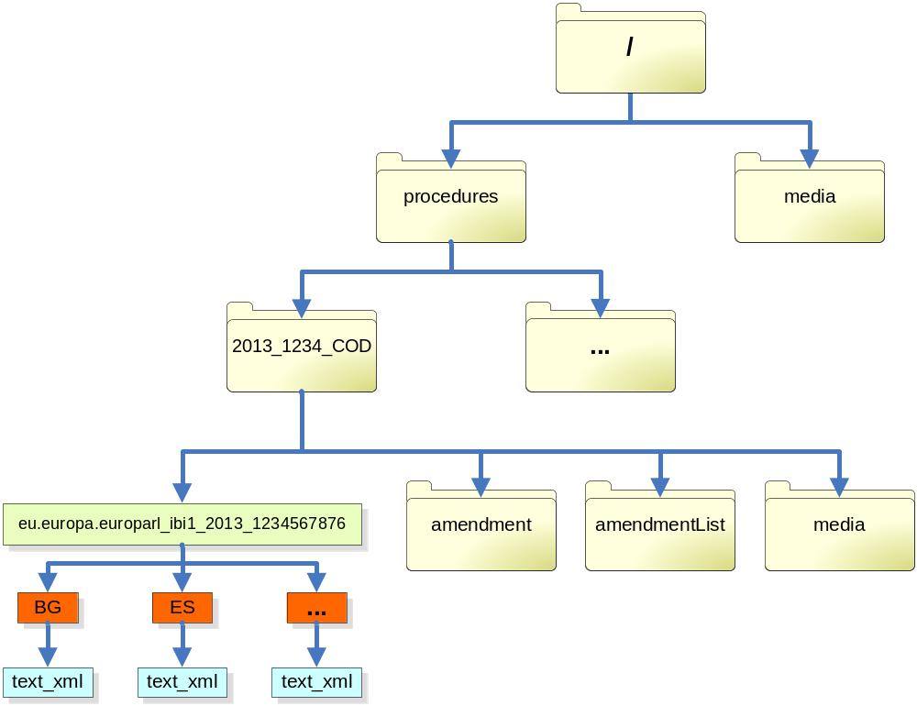
Figure 1 – PURE-XML folder structure
In Figure 1 above, the text inside the yellow boxes (folders) indicate the folder’s name.
The “media” folder under the root folder and the “media” folders for each procedure will be described in paragraph 2.1.6.2 – Media Files.
The amended document is saved directly under the procedure folder, as explained in paragraph 2.2 – Storage of Amended Document.

Amendments and Compilations of Amendments
Logical Units corresponding to XML4EP individual amendments or to compilations of amendments are stored respectively under the “amendment” or “amendmentList” folder. The folder name is extracted from the XML4EP category as described in paragraph 2.1.2 – XML4EP Doc Category. An example is shown in Figure 2 below, where the green boxes are logical units, red boxes physical units and the blue boxes renditions.
The texts inside the boxes indicate the object’s name as an example.
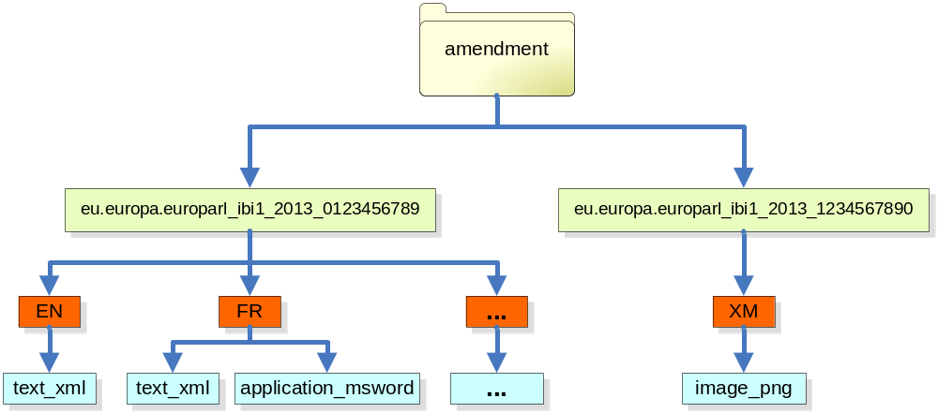
Figure 2 – PURE-XML folder structure for amendment logical units
The renditions stored at the “amendment” level represent an entire individual amendment. Images or other media referenced by an amendment shall be stored under the “media” folder structure as described in the next paragraph.

Media Files
Media files that can be referenced by XML renditions are stored either in the “media” folder under the root folder or in the “media” folders under each procedure.
The “media” folder under the root folder is intended for common (global) media files, such as the EP logo, as shown in Figure 3 below. Specific media files occasionally referenced by XML renditions (for example an amendment containing a MS Excel file that cannot be currently rendered in XML) are stored under the “media” folder of the corresponding procedure, as shown in Figure 4.
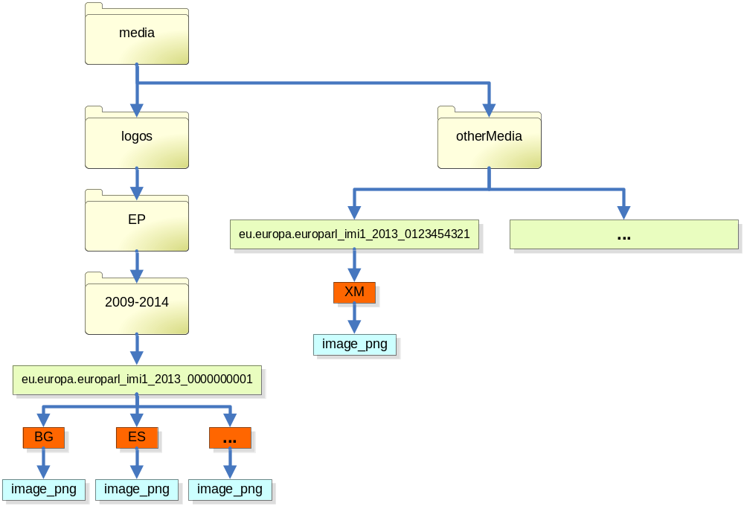
Figure 3 – PURE-XML folder structure for global media files
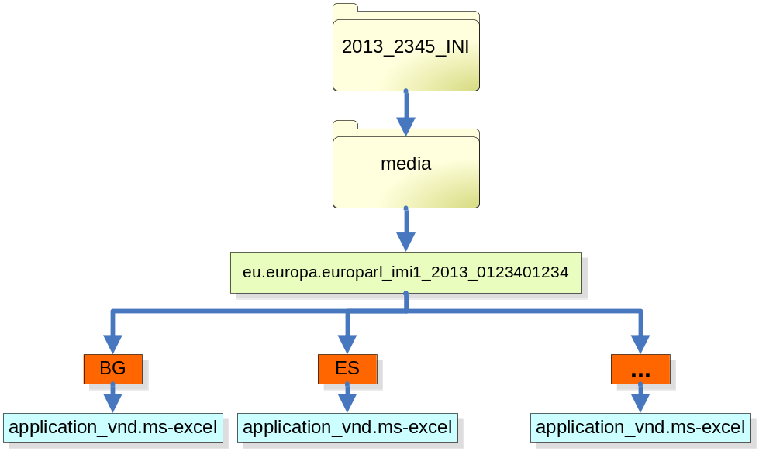
Figure 4 – PURE-XML folder structure for specific media files

Storage of Amended Document
The XMLised document to be amended: Commission legislative proposal, draft committee report, final committee report, etc., shall be stored in PURE-XML so that – for example – it can be retrieved in the translation process and used to fill the “left-hand column” of an AM document in a target language.
The XML content and structure of this document is checked and possibly corrected by DG IPOL IT Functional Team (for amendments in committee) or by Tabling Desk (for amendments in plenary). The XML document must be stored in PURE-XML immediately after this validation, and not before, because amendments are draw up on the basis of the “corrected” XMLised document.
In the framework of the AM Batch interim, the amended document is XMLised by the Document Production Unit based on a specific XML schema; the XMLised document is not compliant with the XML4EP specifications.
As there are few (in most cases only one) amended document per procedure, it shall be saved directly under the procedure folder, as shown in Figure 1 above.
The names of the rendition (for each language) is “text_xml” and the distinction from XML4EP content can be based on the XML schema PURE-XML property of logical units; the proposed value of the XML schema PURE-XML property for the XMLised document is “AT4AM”.
The Content-Types of the XMLised document will be described in paragraph 2.3.1 – Content-Types below.
Note that the authority part of the UDI is “eu.europa.europarl” also for external XMLised document (e.g. Commission or Council documents). This approach is justifiable by the fact that the XMLisation is provided by the European Parliament.
The XML4EP rendition of amendments amending the amended document shall contain a reference to the UBI of the amended document expression (UBI of the physical unit) and the XPath expression pointing to the amended content (e.g. article or recital number).

PURE-XML System and Content Types Properties
Content-Types and Content-Types properties are defined using the PURE-XML management console; Content-Types are assigned at the level of Logical Units. Physical Units and Renditions inherit automatically the Content-Type of their parent (see [4] for further details).

Content-Types
In the framework of the AM Batch interim, the defined Content-Types will be:
- amendment for individual amendments following the “XML4EP” schema.
- amendmentList for amendments batches following the “XML4EP” schema.
- media for media objects.
- baseDocument_AT4AM for an XMLised external document (e.g. COM legislative proposal) in the “AT4AM” schema.
- report_AT4AM for an XMLised draft or final report in the “AT4AM” schema.
- opinon_AT4AM for an XMLised draft opinion in the “AT4AM” schema.
- question_AT4AM for an XMLised draft question in the “AT4AM” schema.
- resolution_AT4AM for an XMLised draft motion for a resolution in the “AT4AM” schema.

Content-Type Properties
In the framework of the AM Batch interim, the only property needed at the Content-Type property level for “amendment” and “amendmentList” Content-Types is the FdR number.
This allows searching for amendments and compilations of amendments via the PURE-XML console using the FdR number as criteria.
It also allows EPS-TPL to extract the FdR number and pass it on to DM-XML for including it in the DocEP document generated from the XML Akoma Ntoso AM document.
The FdR number is the number assigned to a translation request and is erroneously used today as a document identifier. The approach of storing this number in the Content-Type properties avoids the need to save it in the XML as content or as metadata.

Content-Type Rendition-Level XML Metadata
Each Content-Type defined in PURE-XML can be associated to a list of XML metadata definitions and the corresponding XPath expressions, which can be used as search criteria for XML (XML4EP) renditions.
The table below provides a non exhaustive list of possible metadata definitions of some of the content-types required in the AM Batch interim.

Content Type | XML metadata
amendment | author
amendment | amendment number
amendment | ...
amendment list | procedure reference
amendment list | committee
amendment list | ...
Table 2 – Content-Type rendition-level XML metadata examples

PURE-XML System Properties
When saving content in PURE-XML, system properties shall be set following the criteria indicated in the table below.

Name | Description
Folders, Logical Units, Physical Units and Files
Parent | The parent object. See paragraph 2.1.6 – PURE-XML Folder/Name Structure.
Name | The object’s name. See paragraph 2.1 – PURE-XML Folders and Object Names.
UBI | Unique Business Identifier. See the PURE-XML UDI Rules document ([6])
Locked | Must not be set (so that the default “false” value) is taken.
State | Can be optionally set by client applications for simple “life-cycle” support.
Order ID | User-defined order of objects within the sequence of the objects of the parent folder. Can be optionally set by client applications.
Folders, Logical Units and Physical Units
Version Label | Free-text version label. Can be optionally set by client applications, but should not be confused with the UDI version scheme, which is system maintained.
Logical Units
Subject | Semantics message summary. Can optionally be set by client applications.
Security Code | Free-text security classification code. Can be optionally be set by client applications. It does not enforce any access rules on PURE-XML content.
XML schema | Mandatory. It must correspond to the schema of the XML renditions stored under a Logical unit and can take the following values:  “XML4EP” for amendment and amendmentList objects based on the XML4EP schema;  “AT4AM” for the XMLised documents to be amended, produced by the Document Production Unit;  empty in all other cases
Physical Units
Language | Mandatory. Must correspond to the language of the content being stored (“XM” for mixed language content or for content without linguistic information).
Original language | Mandatory. Language code identifier for the original language. Corresponds to the “Language” property in case the original language is being stored. For translations, it must be set to the source language.  In the case of external documents (such as COM legislative proposals) that do not properly have an original language, this property is set to the same value as the Language property.
Physical Units
Media Type | Mandatory. Must correspond to the IANA media-type, for example “text/xml”, “image/png”, etc.
Table 3 – Guidelines for setting PURE-XML system properties.

EPS PURE-XML Service Layer
EPS PURE-XML Service Layer will provide functions facilitating the saving of content in PURE-XML and encapsulating the setting of many PURE-XML properties to the correct values.
The EPS methods for storing content in PURE-XML can be implemented on the basis of the following principles:
- Method for storing XML4EP Content
The client application must provide:
- The procedure reference must be passed as a parameter to EPS by the client application for the first semantic version (e.g.: AT4AM).
EPS will create a folder for the corresponding procedure if such folder does not exist yet.
- The client application must pass as parameter a properties object which must contain the following properties:
- FdR Number (mandatory only for and ‘amendment list’ object)
and can optionally contain the following additional properties:
- State

- Version Label
- Subject
- Security Code
EPS shall raise an exception if the client application does not provide the mandatory properties listed above or if it tries to set other properties.
- The client application must indicate if a major version of the XML4EP content must be created (by default it is minor). This indication is only used for updating existing instances. New XML4EP instances are assigned standard numbering by convention (see the PURE-XML UDI Rules document ([6]).
The EPS “Save XML4EP” function will:
- The XML4EP category can be extracted by EPS from the XML metadata section (see paragraph 2.1.2 - XML4EP Doc Category).
EPS will create a folder for the corresponding document-type element name, if such folder does not exist yet.
- EPS will use the “amendment” or “amendmentList” content-type in function of the XML4EP category (see paragraph 2.3.1 – Content-Types).
- For the logical unit name, EPS can build the name value starting from the UDI provided by the UDI application. The scheme shall be set to “ibi1” for individual amendments logical units and to “DIN1” for amendments lists logical units.
- EPS sets the physical unit name based on the language information extracted from the XML content.
- The name of the rendition will be fixed to “text_xml”
- EPS will set the other PURE-XML and Content-Type properties based on the guidelines listed in Table 3 above.
- Method for storing the XMLised Document
The client application must provide:
- The procedure reference must be passed as a parameter to EPS by the client application.
EPS will create a folder for the corresponding procedure if such folder does not exist yet.
- An additional parameter must specify if the XMLised document concerns a procedure’s base document (e.g. Commission proposal), a committee report, a committee opinion, a question or a motion for a resolution.
EPS uses the value of this parameter for setting the content-type as described in paragraph 2.3.1 - Content-Types.
- The client application must pass as parameter a properties object which must contain the following properties:
- Language
- Content type (baseDocument_AT4AM, report_AT4AM, opinon_AT4AM, question_AT4AM or resolution_AT4AM)
and can optionally contain the following additional properties:
- State

- Version Label
- Subject
- Security Code
- The client application must indicate if a major version of the content must be created (by default it is minor). This indication is only used for updating existing instances. New instances are assigned standard numbering by convention (see the PURE-XML UDI Rules document ([6]).
The EPS “Save XMLised Document” function will:
- The logical unit for the XMLised document will be created directly under the procedure folder.
- For the logical unit name, EPS can build the name value starting from the UDI provided by the UDI application. The scheme shall be set to “DIN1”.
- EPS sets the physical unit name based on the language information passed as parameter by the client application.
- The name of the rendition will be fixed to “text_xml”
- EPS will set the other PURE-XML properties based on the guidelines listed in Table 3 above.
- Method for storing Media objects
The client application must provide:
- The procedure reference must be passed as a parameter to EPS by the client application.
EPS will create a folder for the corresponding procedure if such folder does not exist yet.
- The client application must pass as parameter a properties object which must contain the following properties:
- Language
- Media Type
and can optionally contain the following additional properties:
- State
- Order ID
- Version Label
- Subject
- Security Code
- The client application must indicate if a major version of the XML4EP content must be created (by default it is minor). This indication is only used for updating existing instances. New XML4EP instances are assigned standard numbering by convention (see the PURE-XML UDI Rules document ([6]).
The EPS “Save Media” function will:
- EPS will implicitly use the “media” content type (see paragraph 2.3.1 - Content-Types).
- For the logical unit name, EPS can build the name value starting from the UDI provided by the UDI application. The scheme shall be set to “imi1”.
- EPS sets the physical unit name based on the language information passed as parameter by the client application.
- The name of the rendition will be set based on the Media Type passed as parameter by the client application. EPS will convert forward slashes into the underscore character. Note that the MIME type is not controlled by EPS against the actual content being stored.
- EPS will set the other PURE-XML properties based on the guidelines listed in Table 3 above.

Stages at which Content Must Be Saved in PURE-XML
PURE-XML does not obviously provide any restriction or check on the “opportunity’ to store content in the repository.
PURE-XML client applications operating in the framework of the AM-Batch interim (AT4AM, DST and CAT4TRAD) also have a local database. In order to ensure the consistency of the amendments workflow, it is necessary to define the stages in the workflow when content shall be stored in PURE-XML.
The following table lists the main steps in the amendments workflow and indicates whether content shall be saved in the local application database or in PURE-XML.

Step | Tool | PURE-XML /  Local DB | Notes
Upload XMLised document in AT4AM  (possibly performing corrections) | AT4AM | PURE-XML
Save amendments while drafting / translating | AT4AM / DST / CAT4TRAD | Local DB
Export amendments for review while drafting / verifying / translating | AT4AM / DST / CAT4TRAD | Local DB | If the concerned amendments do not exist yet in PURE-XML, the XML4EP and ZIP libraries will transparently provide temporary IDs for indentifying amendments within an amendment batch.
Submit amendments within draft report / draft opinion | AT4AM | Local DB | Not supported in the AM Batch interim
Submit amendments for tabling in committee or plenary | AT4AM | PURE-XML | First creation of amendments and amendments batches.
Finalise AM document by committee secretariat / submit translation request | AT4AM / ITER | PURE-XML
Save committee amendments during admissibility checks / linguistic verification | DST | Local DB
Book-out verification and admissibility checks of committee documents in TOP with modifications | DST / TOP | PURE-XML
Change amendment content as part of the admissibility check of plenary amendment | DST | Local DB | Operation performed on individual amendments
Change amendment content during linguistic verification of plenary amendments | DST | Local DB | New amendments can be created in this operation
Book-out linguistic verification of amendments in plenary | DST / TOP | PURE-XML | This operation always involves the creation of a new amendment batch and can involve the creation of new amendments.
Submit translation request of a batch of amendments in plenary | TORIS | PURE-XML | Possible update of the official amendment number (the number used for the voting list)
Translate amendments | CAT4TRAD | Local DB
Book-out translation | CAT4TRAD / TFLOW | PURE-XML
Table 4 – Steps in the amendments workflow when content is stored in PURE-XML

At least in the AM List interim, PURE-XML Logical Units will not contain other Logical Units as children. The link between an amendment list and the contained amendments will only exist within the XML Akoma Ntoso content.
XL is intended to indicate the situation where the same content in different languages is present inside the same document. It is actually never used.

